GANPAT UNIVERSITY
U.V.PATEL COLLEGE OF ENGINEERING & TECHNOLOGY
Department of Computer Science and Engineering
B.Tech 1ST Semester Subject – ESFP
First Name:Jainam Enrollment Number:14012111009 Stream:MA

Assignment -1 Date:27/08/14
Goal
Requirements
Deliverable :
1. Source code
Q1. Write a program to print ASCII values of all backslash characters and white space on screen in following format :
The ASCII value of ‘\t’ is : 9
Ans. #include<stdio.h>
#include<conio.h>
void main()
{
char a;
clrscr();
a='\a';
printf("\nthe ascii value of'\\a' is:%d",a);
a='\b';
printf("\nthe ascii value of '\\b' is:%d",a);
a='\f';
printf("\nthe ascii value of '\\f' is:%d",a);
a='\n';
printf("\nthe ascii value of '\\n' is:%d",a);
a='\r';
printf("\nthe ascii value of '\\r' is:%d",a);
a='\t';
printf("\nthe ascii value of '\\t' is:%d",a);
a='\v';
printf("\nthe ascii value of '\\v' is:%d",a);
a='\?';
printf("\nthe ascii value of '\\?' is:%d",a);
a='\\';
printf("\nthe ascii value of '\\\' is:%d",a);
getch();
}
Outcomes / Output 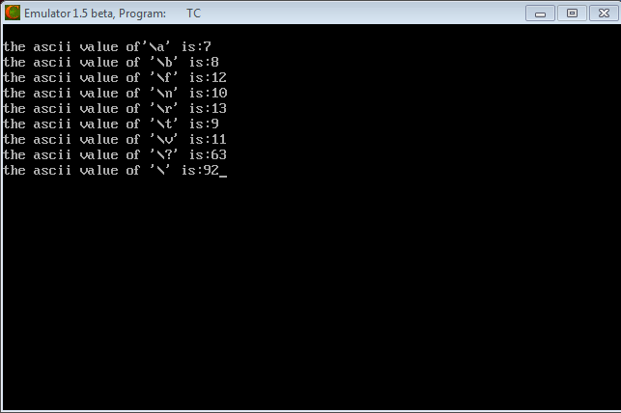
Q2. Explain different data types available in C.
Ans. C has different data types for different types of data and can be broadly classified as :
- Primary data types
- Secondary data types
Primary data types consist following data types.

Data Types in C
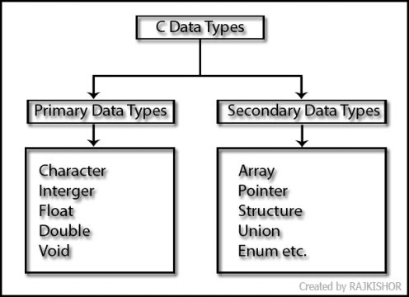Pin It

Character Type:

Integer types:

Floating Data Types:
Double Data Types:

Void Type:

Data Types in C, Size & Range of Data Types.
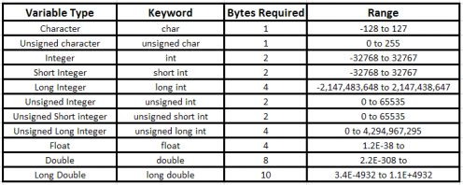

Q3. Explain about C Tokens in brief.
Ans. Tokens are individual words and punctuation marks in passage of text. In C, program the smallest individual units are known as C Tokens. C has Six types of Tokens.
keyword
identifier
constant
string-literal
operator
punctuator
Q4. Explain about backslash characters in C.
Ans. String values in the C language are terminated with null characters (CHAR(0)) and can contain nonprintable characters (such as backspace).
Nonprintable characters are specified by escape sequences. An escape sequence is denoted by using the backslash (\) as an escape character, followed by a single character indicating the nonprintable character desired.
This type of string is specified by using a standard string constant followed by the character C. The standard string constant is then interpreted as a C-language constant. Backslashes are treated as escapes, and a null character is automatically appended to the end of the string (even if the string already ends in a null character).
Escape Sequence | Represents
\a or \A | A bell
\b or \B | A backspace
\f or \F | A formfeed
\n or \N | A new line
\r or \R | A carriage return
\t or \T | A horizontal tab
\v or \V | A vertical tab
\xhh or \Xhh | A hexadecimal bit pattern
\ooo | An octal bit pattern
\0 | A null character
\\ | A backslash (\)

